Tab 1

Iter1.5 Heuristic Evaluation
G3T3
1. No Confirmation or Quick Recovery for the “I’m Okay” status
2. High Risk of False Alarms and Lack of Recovery on Well-Being Checks
3. No Way to Cancel or Undo a Confirmed Ride Booking
4. No Way to Correct a False "Arrived Home" Detection
5. Limited Drink Logging Options
6. Unclear "Need Help" Button Outcome
7. No control over the app once the phone dies
8. Missing Consent for Buddy Location Handoff
9. Location isn't Re-detected After a Last-Minute Plan Change
10. Temporary Disconnection
11. Ambiguous "Go Home Yourself" Button
12. Location Input is Manual Text Entry
13. No Clock Icon/Picker for Time Input
14. Inefficient Manual Selection of Night Buddies
15. Ride Price Is a Fixed Bundle With No Opt-outs
16. No Payment Method Shown Before Confirming Booking
17. Drink "Pace" Rating Has No Explanation
18. Inconsistent Terminology for “Night Buddy”
19. Active Session/Tracking Status is not clearly visible
20. No shortcuts to ensure safety
21. Booking a car home lacks familiar ride-hailing conventions
22. Ending a session jumps straight to booking a car with no warning
23. Inefficient Drink Logging Process
24. Unclear “Safe” / “Missing” Function
25. Alcohol consumption tracker's input controls don't look interactive
26. Missing Header on Drinks Tab
27. Inconsistent Navigation Controls (Back vs. X)
28. Map Pins Only Show a Single Letter
29. Missing Confirm/Update Button on Edit Session
30. Cancel action on check-in screen doesn’t match standard dismissal patterns
31. No Selection or Setup for "Next of Kin"
32. No Check That a "Night Buddy" Actually Has the App
Heuristics and Severity Ratings
These heuristics and severity ratings are provided as a convenience and may be removed.
Heuristics | Severity Ratings
0. Not related to any heuristic  1. Visibility of system status  2. Match between system and the real world  3. User control and freedom  4. Consistency and standards  5. Error prevention  6. Recognition rather than recall  7. Flexibility and efficiency of use  8. Aesthetic and minimalist design  9. Help users recognize, diagnose, and recover from errors  10. Help and documentation | 0 = Not a real usability problem  1 = Cosmetic problem only  2 = Minor usability problem  3 = Major usability problem  4 = Usability catastrophe

Evaluators
- Jessie Ong
- Phang Kah Yeng
- Stephanie Ong Sok Chin
- Teh Chai Wen
- Yee Wan Sim
- Cheyenne Loh Wenjun
- Ho Yi Victoria

Compiled Usability Problems

No Confirmation or Quick Recovery for the “I’m Okay” status
Source(s): C1
Heuristic: 5. Error prevention
Severity: 3 = Major usability problem
Description: There is no confirmation step after pressing the “I’m Okay” button, and while an SOS button does exist, it is buried inside a separate Nav Bar tab rather than being immediately accessible. This means that a user who accidentally presses "I'm Okay" in a dark, crowded, or intoxicated state may struggle to quickly navigate to and activate SOS when they do need help.
Fix: Add a brief confirmation dialogue after the "I'm Okay" button is clicked (e.g., "Are you sure you're safe?") and make the SOS button persistently accessible from every screen. For example, it could be a floating button, rather than requiring users to navigate to a different tab to find it.
Notes: We downgraded this severity to 3 as we recognize the high usability friction, but don’t believe it is necessarily catastrophic. Firstly, the SOS button is not actually buried inside a separate nav bar tab, and instead sits above the nav bar. Secondly, we do not believe the proposed fix is suitable for our app as we do not want additional user friction in the well-being check-in process. Instead, we will change the “Need Help” button to a red Slide-to-confirm button labelled “Need Help”. This way, it will prevent any accidental SOS triggers, whilst keeping the “I’m Okay” button easily accessible. In the event a user accidentally clicks “I’m Okay”, they can easily access the SOS button after the popup disappears.
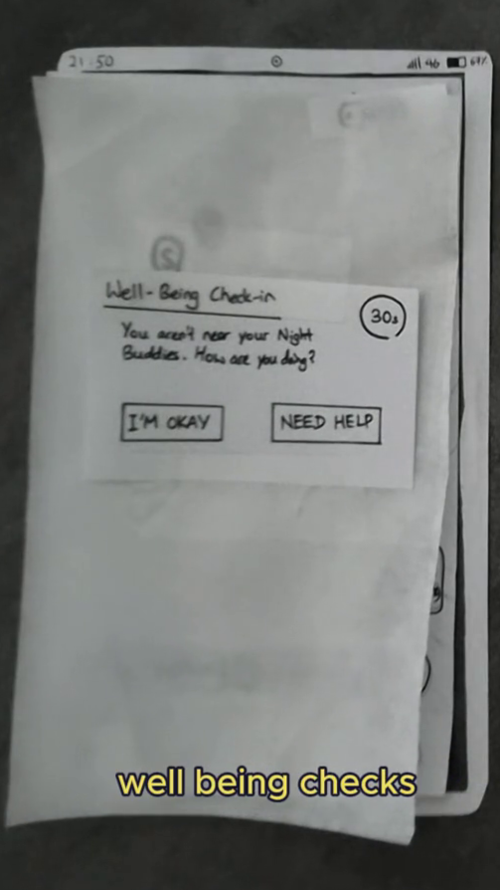 → 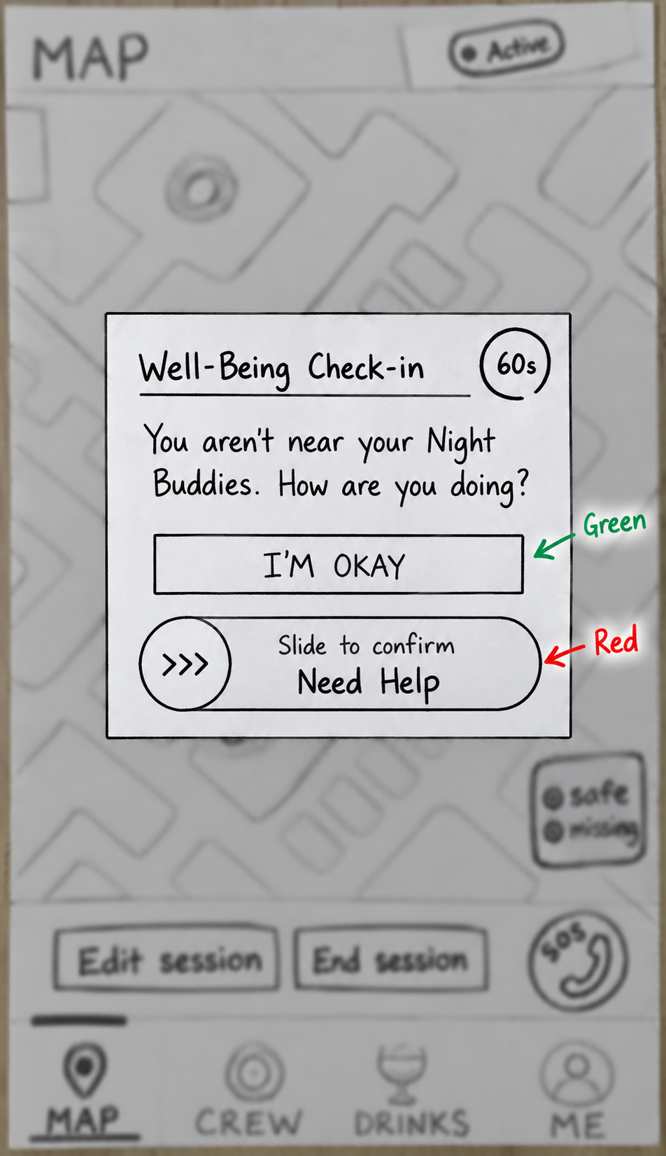

High Risk of False Alarms and Lack of Recovery on Well-Being Checks
Source(s): D2, F4
Heuristic: 5. Error prevention, 9. Help users recognize, diagnose, and recover from errors
Severity: 3 = Major usability problem
Description: The well-being check imposes a strict 30-second time limit, making it highly likely to be missed in loud or distracting environments and causing frequent false alarms. Furthermore, once an alert is triggered and sent, users are provided no recovery action to inform the app, their buddy, or their next-of-kin that they are actually safe.
Fix: Increase the response window to 3-5 minutes and implement an escalating alert system to prevent initial false alarms. Additionally, allow users to verify their safety in the app even after an alert is sent, and notify the next of kin to confirm safety if they successfully contact the user directly.
Notes: We agree with the evaluators’ severity and descriptions, but would like to implement a different fix. We will firstly increase the well-being check response window to 60 seconds and introduce progressive escalation. A standard notification will be played at first. After 30 seconds of unresponsiveness, the device will vibrate to warn the user that their Night Buddy and Next-of-kin will be notified if they are still unresponsive. If the 60-second timer expires, a new 60-second timer will start and the user’s Night Buddies will be alerted that the user is unresponsive. The user can still confirm that they are safe after an alert has been sent, which will automatically send a follow-up notification informing the Night Buddies that the user is safe. If the user remains unresponsive, the alert will subsequently escalate to their next-of-kin.
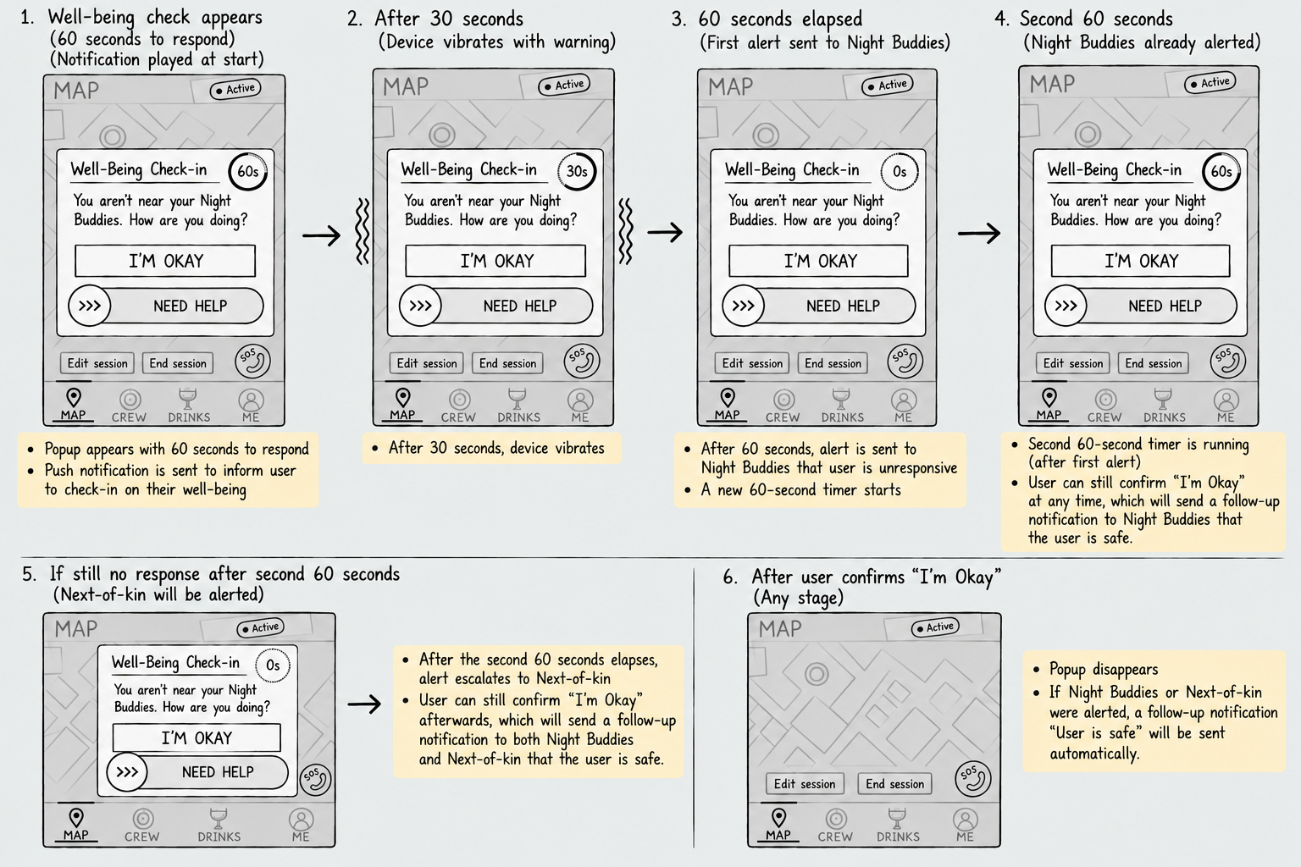

No Way to Cancel or Undo a Confirmed Ride Booking
Source(s): A2
Heuristic: 3. User control and freedom, 7. Flexibility and efficiency of use
Severity: 3 = Major usability problem
Description: Once a booking is confirmed, there is no undo or "exit" from that action, the booking screen only shows "Confirm Booking" or "Go Home Yourself" beforehand, with nothing after. If a driver is booked by mistake or plans change, users have no way to back out.
Fix: Add a visible "Cancel Booking" option for a short grace period after confirming, similar to GrabFood's cancellation window.
Notes: We agree with this issue and its severity and will add separate screens to cancel or undo a ride booking, similar to how other ride hailing apps like Grab does. 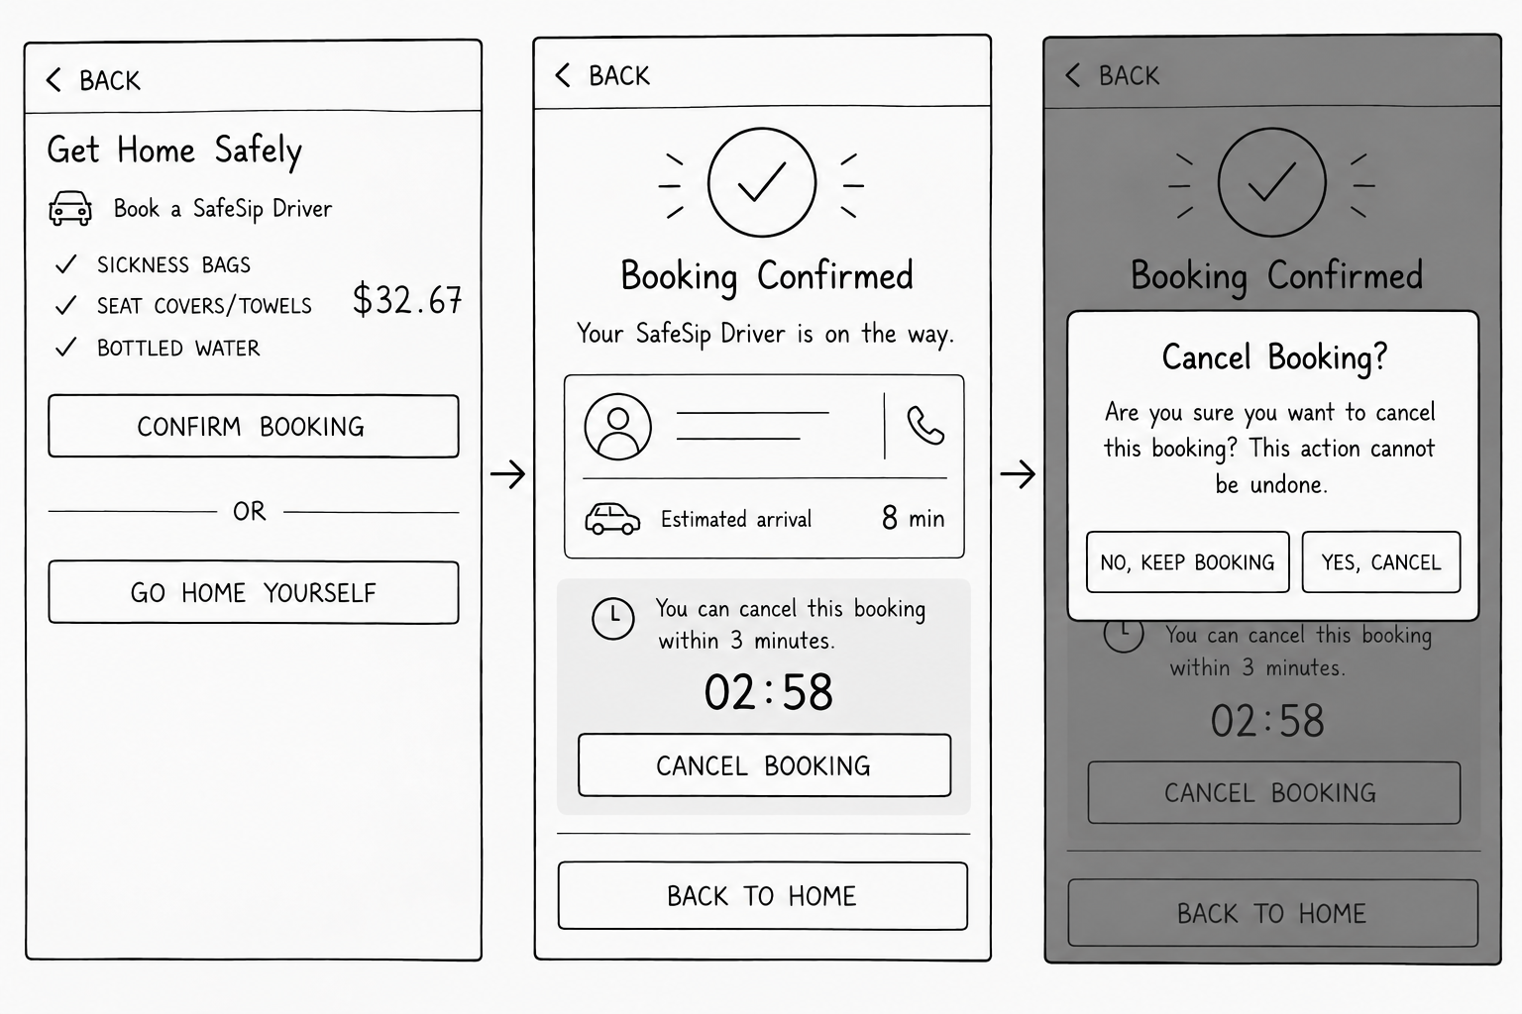

No Way to Correct a False "Arrived Home" Detection
Source(s): B2
Heuristic: 9. Help users recognize, diagnose, and recover from errors
Severity: 3 = Major usability problem
Description: Once the app geofences the user as home, it automatically ends the session and sends parents an "Arrived Home! Have a good rest!" message, with no option to flag "not actually home yet" if the location trigger is wrong. A false positive gives worried contacts false reassurance.
Fix: Instead of auto-ending the session, show a "Confirm Your Arrival" screen when the app detects the user near home, asking "Have you actually arrived?" with two options: "Yes, I'm Home" and "Not Yet / Still Out." Only send the "safe" notification to parents once the user confirms, so a false GPS trigger gets caught before contacts are told anything.
Notes: We agree with this issue and its severity, and will implement the fix the evaluator suggested, where we will introduce a confirmation popup for the user to confirm that they have arrived home safely to prevent false arrivals.
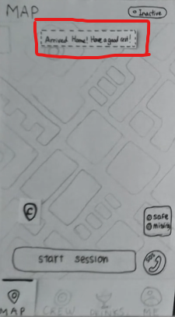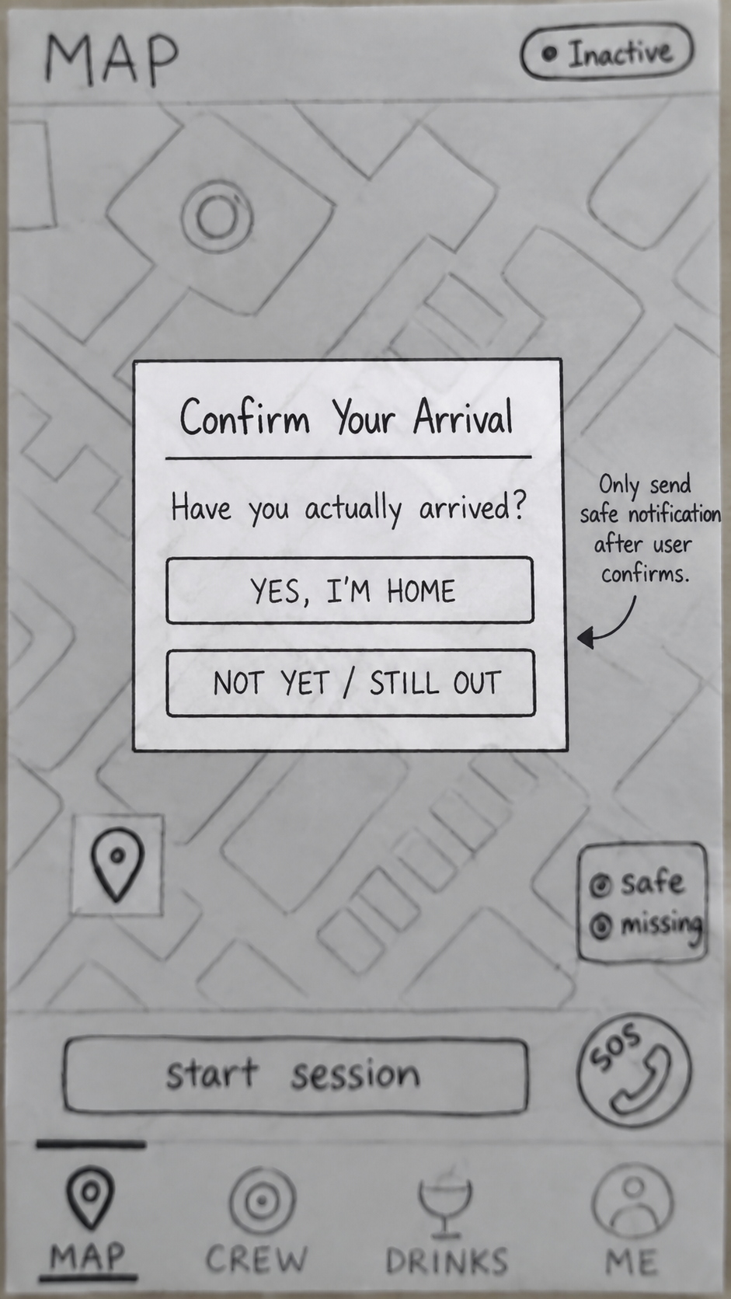
Old Screen - Automatic Detection Fix - Automatic Detection with Confirmation

Limited Drink Logging Options
Source(s): C3
Heuristic: 2. Match between system and the real world
Severity: 3 = Major usability problem
Description: The drink tracker only offers 6 preset drink-type buttons with no "other" option, making it difficult to log other common scenarios (e.g., mixed drinks, highball, mocktail, etc.) accurately.
Fix: Include a custom/"other" entry option and implement a gentle reminder nudge if no drinks have been logged after a period of time (e.g. after 15 minutes) during an active session, as an added safety.
Notes: We agree with the severity of this issue, and will implement a custom “Other” entry option as there are other drinks besides the current range of options with different alcohol amounts. However, we think prompting the user after they have not logged a drink in a period of time is not ideal as it can get repetitive, especially for users who don’t necessarily drink much that use the app.
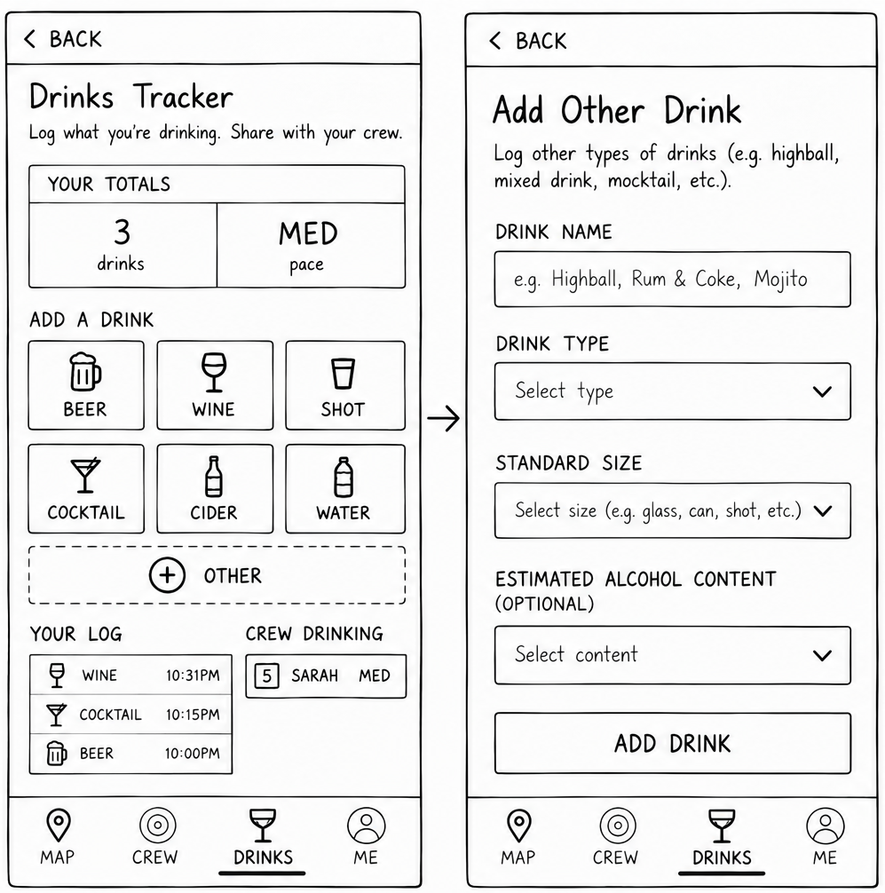

Unclear "Need Help" Button Outcome
Source(s): F2
Heuristic: 10. Help and documentation
Severity: 3 = Major usability problem
Description: The "Need Help" button during a well-being check lacks context regarding what exact action it triggers, meaning users in distress might hesitate to press it if they do not know whether it alerts parents, calls emergency services, or messages the buddy.
Fix: Have the button expand into distinct, explicitly labeled choices like "Call Buddy" or "Alert Parents."
Notes: We agree with this issue’s severity and will implement a popup screen to allow users to choose to SOS call their next-of-kin or Night Buddies.
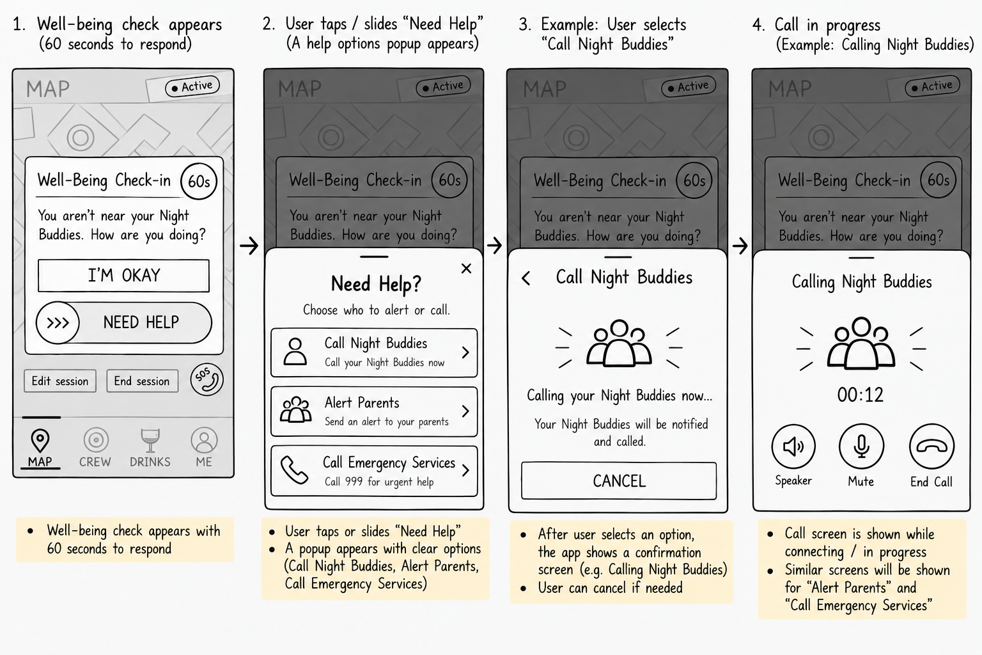

No control over the app once the phone dies
Source(s): D1
Heuristic: 3. User control and freedom
Severity: 2 = Minor usability problem
Description: The control of confirming the user’s safety is transferred to the buddy’s phone once the user’s phone dies, leaving the user with absolutely no control to confirm for his/her own safety.
Fix: App could suggest nearby places with portable power banks when user’s phone is running low on battery or enable pairing with wearable devices.
Notes: We downgraded this severity to 2 as we do not believe the issue is necessarily catastrophic, but do agree that it is a minor usability problem. While the powerbank locations are helpful, we don’t believe it solves the underlying failure state. Instead, we will work on better “Low-battery escalation” features such as informing the user and Night Buddies of low batteries proactively, and explicitly letting users know the next steps the app will take if the device cannot be charged and loses power abruptly (Switch to proactive well-being checks on Night Buddy’s device)

Missing Consent for Buddy Location Handoff
Source(s): F1
Heuristic: 3. User control and freedom
Severity: 2 = Minor usability problem
Description: Although a friend is registered as a "Night Buddy" for the session, this does not automatically imply they consent to sharing their personal live location with the primary user's parents. When the primary user's phone battery is about to die, the app seamlessly switches to tracking the buddy without ever asking the buddy for permission to broadcast their location data.
Fix: Implement a permission prompt on the buddy's device when their phone’s battery is low, asking for explicit consent to temporarily share their location with the next-of-kin if the primary user's device fails.
Notes: We downgraded the severity of this issue to 2 as we Night Buddies are obtained from the user’s contacts, hence we assume they are close enough to not mind sharing location with the user’s next-of-kin. However, we will add a privacy disclaimer on the sign up screen as a compromise.

Location isn't Re-detected After a Last-Minute Plan Change
Source(s): B3
Heuristic: 5. Error prevention
Severity: 2 = Minor usability problem
Description: The app can auto-detect arrival at the pre-planned venue via GPS, but when the group spontaneously switches venues, it doesn't offer to auto-update. The user must remember to manually open "Edit Session" and retype the new location, so a forgotten update leaves emergency contacts with a stale, wrong location.
Fix: When the app detects the user has left the original venue and stayed at a new location for a few minutes, prompt them to confirm and auto-fill the new venue into the session instead of requiring a fully manual edit.
Notes: We downgraded the severity to 2 as we do acknowledge the inconvenience, but don’t believe it warrants a severity of 3. We will implement the evaluator’s proposed fix, and add a proactive prompt to check if the user wants to change his location in the event of a spontaneous change of plan.

Temporary Disconnection
Source(s): D3
Heuristic: 5. Error prevention
Severity: 2 = Minor usability problem
Description: Device is paired locally, which may temporarily be disconnected and can trigger false check-in.
Fix: App could notify user and his/her buddy that their devices are disconnected first and allow a grace period of 30 seconds to allow user and buddy to get back to connection before starting to send well-being check-in.
Notes: We downgraded the severity of this issue to 2 as the app only sends well-being checks every 30 minutes when the user is far apart from their Night Buddies or if their device runs out of battery (location cannot be tracked). This timer does not run when the user is within close proximity with his “Night Buddy”, so a temporary loss in connection will not result in a well-being check, given they are reconnected within 30 minutes. As such, we find the evaluator’s concerns that unstable local connections in crowded clubs causing the app to falsely assume separation, potentially spamming them with well-being check-ins, completely valid. However, this does not necessarily cause a major usability issue and does not require a fix as we consider the 30-minute grace window more than enough.

Ambiguous "Go Home Yourself" Button
Source(s): F3
Heuristic: 4. Consistency and standards
Severity: 2 = Minor usability problem
Description: The phrasing "Go Home Yourself" leaves users unsure if tapping it completely terminates the active safety tracking session or simply skips the partnered car booking while maintaining live tracking.
Fix: Rename the button to follow standard platform conventions, such as "Skip Booking" or "Arrange My Own Ride," and display a brief notification confirming that live tracking remains active.
Notes: We downgraded the severity of this issue from to 2, as while the ambiguous wording may cause users to be uncertain whether “Go Home Yourself” only skips the ride-booking process or also ends the active safety tracking session, it does not prevent them from completing their intended task and can be easily resolved through clearer wording. Hence, we will follow the proposed change and rename the option to “Arrange My Own Ride” then provide a brief confirmation that the app will continue tracking the user’s journey home.

Location Input is Manual Text Entry
Source(s): G1
Heuristic: 5. Error prevention
Severity: 2 = Minor usability problem
Description: The location field currently requires manual text input rather than letting users select from a map, increasing the risk of incorrect or invalid entries.
Fix: Replace or supplement the text field with a "select from map" option or autocomplete address suggestions (e.g., Google Places API) to reduce input errors.
Notes: We downgraded this issue’s severity to 2 as we don’t consider this a major usability issue. Our app will already utilize external APIs to help users autocomplete addresses as they type them out. However, we will consider allowing users to have the option to “Select from Map”

No Clock Icon/Picker for Time Input
Source(s): G3
Heuristic: 5. Error prevention
Severity: 2 = Minor usability problem
Description: The "Start session" time field lacks a clock icon or picker, offering no clear affordance for how to enter a valid time. Without a constrained input method, users may type free-text values in inconsistent formats, leading to errors.
Fix: Add a time picker (with a clock icon as the trigger) that lets users select a valid time from a scrollable/wheel or clock-face UI, rather than typing free text — preventing malformed or invalid time entries before they happen.
Notes: We downgraded this issue’s severity to 2 as we don’t consider this a major usability issue. However, we will implement the proposed changes to standardize data input by our users. It can be visually similar to the clock app on phones

Inefficient Manual Selection of Night Buddies
Source(s): A5, C4
Heuristic: 6. Recognition rather than recall, 7. Flexibility and efficiency of use
Severity: 2 = Minor usability problem
Description: Users must manually scroll through and select Night Buddies from their full contact list every time they start a session. The lack of search functionality, filters, or shortcuts for repeat selections makes this process highly tedious and inefficient for users with long contact lists.
Fix: Replace the manual checkbox list with a dynamic search bar, and tab groups of "Recently Selected" and "Favourites", such that repeat Night buddies can be added easily.
Notes: We agree with the severity of this issue and will implement the proposed fixes from evaluators A and C.

Ride Price Is a Fixed Bundle With No Opt-outs
Source(s): A3
Heuristic: 2. Match between system and the real world, 3. User control and freedom
Severity: 2 = Minor usability problem
Description: The ride booking presents a fixed price bundle without allowing users to opt out of individual components they may not need. If the user is not sick or already has water, they still have to pay for the sickness bag, water and seat cover. Users have no control over what they pay for, and this may cause users to pay for unnecessary services. The current setup also deviates from the add-on options convention that users are familiar with from similar ride-hailing and delivery apps.
Fix: 1) Add checkboxes to allow users to select or deselect individual ride options where applicable
2) Clearly display the total after each selection or deselection of each option before
Notes: We agree with the severity of this issue and will implement the proposed fixes.

No Payment Method Shown Before Confirming Booking
Source(s): A4
Heuristic: 1. Visibility of system status, 3. User control and freedom
Severity: 2 = Minor usability problem
Description: The booking confirmation screen shows a price but never indicates how the user will be charged, for example, via a saved card, cash, or wallet. This leaves the user unsure what will happen when they tap "Confirm Booking." Users have no way to review or change how they want to be charged.
Fix: 1) Display the payment method above the Confirm Booking button. For example, "Visa •••• 4321".
2) Let users tap it to change the payment method before confirming.
Notes: We agree with the severity of this issue and will implement the proposed fixes.

Drink "Pace" Rating Has No Explanation
Source(s): B4
Heuristic: 10. Help and documentation
Severity: 2 = Minor usability problem
Description: The Drinks Tracker shows a LOW/MED/HIGH "pace" label next to the drink count, but nothing on screen defines what triggers each level or what the user is supposed to do once they see it. Without that context, the label is just a word with no actionable meaning.
Fix: Add a small info icon or tooltip next to the pace label explaining how it's calculated (e.g. drinks per hour) and what action is recommended at each level.
Notes: We agree with the severity of this issue and will implement the proposed fixes.

Inconsistent Terminology for “Night Buddy”
Source(s): C5
Heuristic: 4. Consistency and standards
Severity: 2 = Minor usability problem
Description: The app inconsistently labels the same feature. "Crew" is used in the Nav Bar tab and Drink Tracker, while "Night Buddy" is used during session setup and throughout the scenario narrative. This may lead users to believe it is two separate features or groups.
Fix: Standardise on a single term across the entire SafeSip app (e.g. “Night Buddy” or “Buddies”) and update all labels and tabs to match. This ensures consistency in both terminology and iconography.
Notes: We agree with the severity of this issue and will implement the proposed fixes.

Active Session/Tracking Status is not clearly visible
Source(s): D4, E5
Heuristic: 1. Visibility of system status
Severity: 2 = Minor usability problem
Description: Although SafeSip includes a small active/inactive indicator, it is too subtle to reliably reassure users that their safety session and location tracking are still running in the background. During a night out, users may overlook the small indicator and become uncertain whether SafeSip is still actively tracking them.
Fix: Make the active tracking state more prominent, such as increasing the size or placing the indicator near the “End Session”/”Edit session” buttons. A persistent notification could also reassure users that tracking remains active while the app is running in the background.
Notes: We downgraded the severity of this issue from to 2 as the app already provides an active/inactive session indicator, allowing users to determine whether their session is active. However, we acknowledge that the current indicator may be too subtle and could cause users to overlook their tracking status. Instead of increasing the size of the indicator, which may create unnecessary visual clutter, we will introduce a subtle glowing animation to improve its visibility while maintaining the existing interface design. We will also include clearer status text, such as “Session Active – Tracking On”, so users can recognise their tracking status at a glance. Additionally, we will add a persistent notification that will be displayed on the user’s device throughout an active session, allowing them to easily verify that the app is still active and tracking their location even when the app is running in the background.

No shortcuts to ensure safety
Source(s): D5
Heuristic: 7. Flexibility and efficiency of use
Severity: 2 = Minor usability problem
Description: For the well-being check-in, it requires users to be inside the app to press the buttons to be able to ensure his/her own safety or to seek help.
Fix: Add shortcuts of safety and seek help buttons to press in the lock screen.
Notes: We agree with the severity of this issue and will implement the proposed fixes.

Booking a car home lacks familiar ride-hailing conventions
Source(s): E2
Heuristic: 2. Match between system and the real world
Severity: 2 = Minor usability problem
Description: The screen for car booking deviates from the mental model users already have from widely used ride-hailing apps like grab (e.g. map preview with pickup/drop off pins, fare estimate). Users may hesitate or misinterpret the screen’s fields and controls when the layout doesn’t match their expectations.
Fix: Redesign the booking screen to follow the familiar Grab style layout. A map view with the route highlighted, estimated far, arrival time and a prominent “Book” call to action. This is so that users can rely on existing habits instead of learning a new interaction.
Notes: We agree with the severity of this issue and will implement the proposed fixes.

Ending a session jumps straight to booking a car with no warning
Source(s): E4
Heuristic: 3. User control and freedom
Severity: 2 = Minor usability problem
Description: Tapping “End Session” immediately goes to booking a car with no confirmation step in between. Although there’s a “back” button on that page, users are not told in advance that ending a session will trigger a car-booking flow. So the jump can feel abrupt or unexpected.
Fix: Add a brief confirmation step before ending the session (e.g. “End session and get a ride home?”) so users know what happens next, rather than discovering it only after landing on an unexpected screen.
Notes: We agree with the severity of this issue and will implement the proposed fixes.

Inefficient Drink Logging Process
Source(s): F5
Heuristic: 7. Flexibility and efficiency of use
Severity: 2 = Minor usability problem
Description: To log a drink, users must repeatedly unlock their phone, open the app, navigate to the tracker, and tap a specific drink type, creating high friction for a frequent, repetitive action.
Fix: Directly add the drinks from the lock screen widget.
Notes: We acknowledge this issue and its severity of 2, as the repeated need to unlock the phone, open the app and navigate to the Drinks Tracker may introduce additional friction when logging drinks throughout an active session. However, while the proposed lock-screen widget could improve the efficiency of this process, implementing such a widget falls outside the scope of our current prototype. As users are still able to log their drinks through the existing Drinks Tracker without being prevented from completing the task, we consider this a minor usability issue and will defer the proposed lock-screen functionality for future development.

Unclear “Safe” / “Missing” Function
Source(s): C2
Heuristic: 1. Visibility of system status
Severity: 1 = Cosmetic problem only
Description: The "Safe" and "Missing" text appear inside a rounded rectangle with no label or explanation of what tapping them does, who is notified, or whether they're a status indicator versus an actionable button.
Fix: If it is meant to be an actionable button, add clear microcopy beneath or within the buttons (e.g., "Tap to notify your Night Buddy & Next-of-kin that you're safe") and include a first-time onboarding tooltip explaining exactly who receives the alert and what happens next.
Notes: We downgraded the severity of this issue to 1 as we believe this is purely a cosmetic issue due to the lack of a “Legend” title in the box. The “Safe” and “Missing” text are supposed to be part of a legend tab, and not an actionable button. Due to the nature of the low fidelity prototype, there were no colours. The actual pins will be coloured based on the legend to indicate whether that user is safe or missing.

Alcohol consumption tracker's input controls don't look interactive
Source(s): E1
Heuristic: 8. Aesthetic and minimalist design
Severity: 1 = Cosmetic problem only
Description: The “add a drink” buttons (beer, wine…) looks like read-only display boxes as it has a similar outline/test as the other items in the page. This violates the aesthetic and minimalist design as the interface gives no visual signal to distinguish an actionable element from static information. As a result, it’s hard to tell that these boxes are actually buttons for logging a drink and not just labels.
Fix: Add a “+” for each drink button to show that tapping it adds an entry. This helps to give the user a clear and familiar cue that the button does an “add” action. A small icon representing each drink type (e.g. a mug for beer, glass for wine) can also be added beside or above the label. This helps users recognize options faster than reading text alone
Notes: We downgraded this issue’s severity to 1 as we don’t consider this issue to be a major usability issue, and merely a cosmetic issue being exacerbated by low-fidelity design constraints. However, we will implement adding a “+” icon to each drink button for better visibility.

Missing Header on Drinks Tab
Source(s): G5
Heuristic: 4. Consistency and standards
Severity: 1 = Cosmetic problem only
Description: The Drinks tab lacks a header, unlike other tabs in the app, breaking the consistent page structure and making it harder for users to confirm which section they're viewing.
Fix: Add a header to the Drinks tab matching the style and placement used on other tabs, ensuring consistent page identification throughout the app.
Notes: We downgraded this issue’s severity to 1 as it is not really a usability issue and merely a cosmetic issue. However, we will still implement the fix proposed for it.

Inconsistent Navigation Controls (Back vs. X)
Source(s): G2
Heuristic: 4. Consistency and standards
Severity: 1 = Cosmetic problem
Description: Some screens use a "back" arrow while others use an "X" to close or exit, making it unclear whether an action will return the user to the previous screen or exit the flow entirely.
Fix: Standardize navigation: use "back" (←) for returning within a flow, and "X" only for dismissing modals or fully exiting a task, applied consistently app-wide.
Notes: We downgraded this issue’s severity to 1 as it is standard practice for popup modals to utilize “x” icons to close. We also don’t agree with the proposed solution and will stick to the standard practice of using “x” icons to close out of popup modals.

Map Pins Only Show a Single Letter
Source(s): B1
Heuristic: 6. Recognition rather than recall
Severity: 1 = Cosmetic problem
Description: On the MAP screen, buddies are shown as pins with just one letter inside (e.g. "S" for Sarah, "C" for Chloe) no name, avatar, or color key anywhere. With more than a couple of buddies, or two people sharing an initial, there's no way to tell who's who at a glance.
Fix: Add the buddy's name as a label under the pin, or give each buddy a distinct color/avatar. Alternatively, let the user hover or tap the pin to reveal the full name on the side, so identity doesn't rely on remembering which letter belongs to whom.
Notes: We downgraded this issue’s severity to a 1 as we already have a separate popup that will appear on click of a map pin with a detailed overview of the user, including their full username, last status update, current location, phone number, battery percentage, and options to either call or text them. However, we understand the evaluator’s concerns and will replace the pins with the user’s profile image instead (Default being their first initial with a coloured background).

Missing Confirm/Update Button on Edit Session
Source(s): G4
Heuristic: 5. Error prevention
Severity: 0 = Not a real usability problem
Description: When editing a session, there is no explicit "Confirm" or "Update" button, leaving users uncertain whether their changes have been saved or if they need to take further action to commit the edit.
Fix: Add a clearly labeled "Update" or "Save Changes" button at the end of the edit flow, and show a confirmation message once the update is successfully saved.
Notes: We downgraded this issue’s severity to a 0 as we already have this feature utilizing a “Confirm Edits” button.

Cancel action on check-in screen doesn’t match standard dismissal patterns
Source(s): E3
Heuristic: 4. Consistency and standards
Severity: 0 = Not a real usability problem
Description: The check in screen uses a text/button labeled “I’m okay” instead of a cross close icon that is the standard for dismissing a modal or step in most mobile UIs. This may cause users to take a longer time to find out where to click.
Fix: Replace the “I’m okay” button with a standard cross icon placed in the typical top-right corner, keeping it visible and consistent with dismiss controls elsewhere in the flow. So the user only clicks on “need help” else the user will close the pop up using the cross.
Notes: We downgraded the severity of this issue to 0, as the well-being check is intentionally designed to require an explicit response from the user rather than allow the popup to be dismissed. Replacing the “I’m Okay” button with an “x” could introduce further ambiguity, as an “x” typically represents dismissing a popup rather than actively confirming the user’s well-being. Hence, we will retain the current popup options, with “I’m Okay” presented as a green button and “Need Help” as a red slide-to-confirm button (as proposed in Issue 1’s fix). This provides a clear distinction between the two actions while reducing the risk of accidentally triggering an SOS without introducing unnecessary friction to the well-being check-in process.

No Selection or Setup for "Next of Kin"
Source(s): A1
Heuristic: 1. Visibility of system status, 3. User control and freedom
Severity: 0 = Not a real usability problem
Description: There is no setup function for “Next of Kin”, users cannot view, choose, or change who this contact is. Users are also not able to select who should be alerted when creating a session. This removes the user's control over a safety-critical setting and risks alerts not reaching the intended person.
Fix: 1) Show the currently-configured Next of Kin in the “Me” tab so users can verify it's set, and allow users to add or edit.
2) Add a selection box during each session setup, with an option to review or change the selected contact.
Notes: We downgraded the severity to 0 as this is handled beforehand during account creation, where users will select their next-of-kin.

No Check That a "Night Buddy" Actually Has the App
Source(s): B5
Heuristic: 5. Error prevention
Severity: 0 = Not a real usability problem
Description: Night Buddies are picked from the phone's contact list, but nothing checks if that contact actually has SafeSip installed. If they don't, that buddy never gets notified, and the app never tells the user.
Fix: When a contact without the app is selected as a Night Buddy, show a warning and offer to send them an invite/download link, so the user knows their safety net has a gap.
Notes: We downgraded the severity of this issue to 0 as our app will automatically only populate Night Buddies based on the user’s contacts who already created an account on the app.

